AI Tool Citation

As given in the Syllabus Copy
• Proper Citation: If AI tools are used to assist with any aspect of your work, you must:
1) Clearly cite the specific AI tool used.
2) Provide a brief explanation of how it contributed to your work.
3) Why used.

- Used these tools Anaconda Assistant (version 4.18.0) and ChatGPT (OpenAI GPT-4, March 2023 version).
- Used these tools to understand the syntaxes and definitions of certain functions used in the code.
Eg:
- Binning Age.
- Removing Extra Bins (which are created before analyzing boxplots).
- Suppressing Unwanted Output in Jupyter.
- Does it take a long time to render them if the data is huge.

- Anaconda Assistant (Screen Shots)
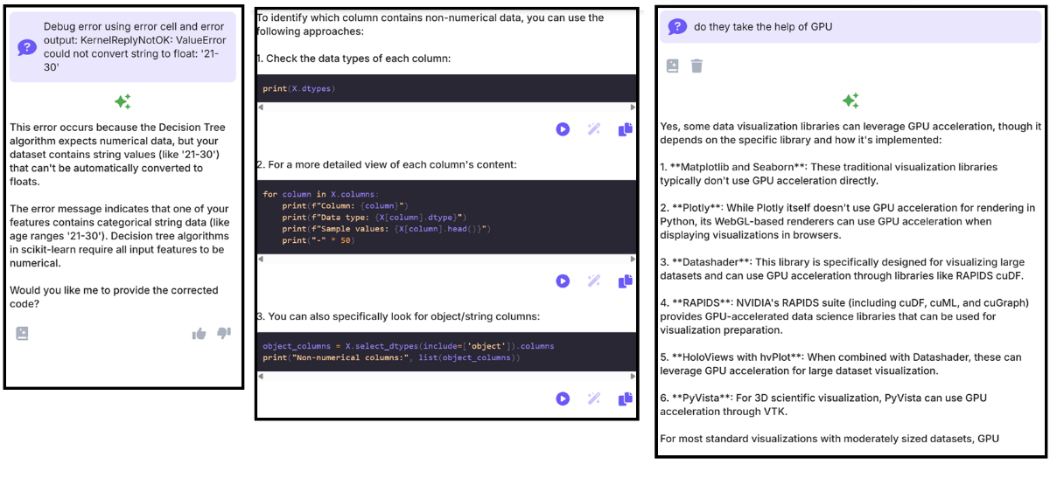

- ChatGPT (Screen Shots)
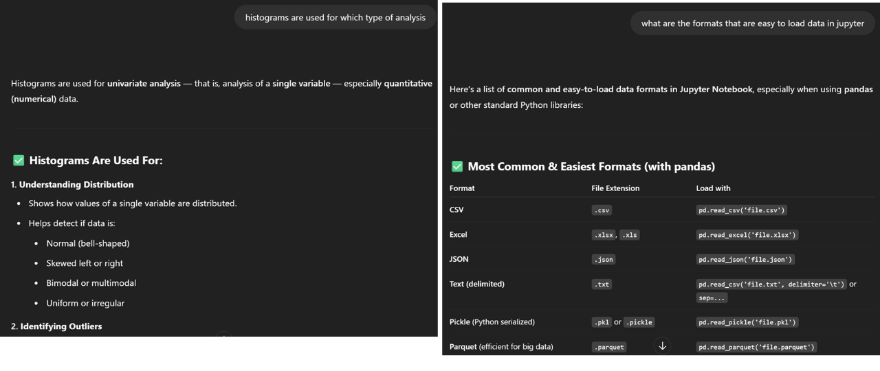
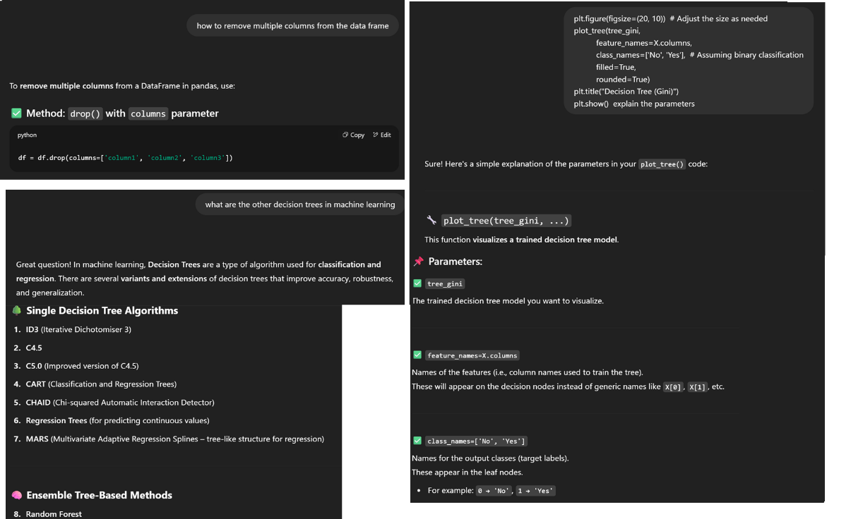

- To get better understanding of the code and in-depth knowledge required for implementing the concepts with the tools.

Below is the usage of ChatGPT

This was used as a much faster version of indexing than digging through documentation to find syntax and calling conventions.

Please Index the sklearn docs and summarize the decision trees section for Gini impurity and entropy
ChatGPT said:
Here’s the overview of scikit-learn’s Decision Trees documentation, followed by a clear summary of the Gini impurity and entropy (information gain) criteria:

📚 Index: scikit-learn Decision Trees Guide
From the User Guide’s 1.10. Decision Trees section stackoverflow.com+9scikit-learn.org+9scikit-learn.org+9:
- Introduction & motivation
- Classification (DecisionTreeClassifier)
- Regression (DecisionTreeRegressor)
- Splitting criteria (Gini, entropy, log-loss)
- Tree construction process and parameters
- Impurity calculation and node splitting
- Pruning techniques (e.g., cost-complexity pruning)
- Visualization and inspection tools

🧠 Splitting Criteria
1. Gini Impurity
- Definition:
Gini=1−∑ipi2=∑ipi(1−pi) Gini = 1 - \sum_i p_i^2 = \sum_i p_i (1 - p_i)Gini=1−i∑​pi2​=i∑​pi​(1−pi​)
where pip_ipi​ is the proportion of class iii at a node stackoverflow.comdatacamp.com+3en.wikipedia.org+3medium.com+3scikit-learn.orglowyx.com.
- Interpretation:
Reflects probability of misclassifying a sample if labeled randomly according to class distribution. Pure nodes (one class) ⇒ Gini = 0; maximal impurity for two equal classes ⇒ Gini = 0.5 quantdare.com+4lowyx.com+4medium.com+4.
- Gini Gain:
ΔGini=Giniparent−∑child nodesnchildnparent Ginichild \Delta Gini = Gini_{\text{parent}} - \sum_{\text{child nodes}} \frac{n_{\text{child}}}{n_{\text{parent}}} \, Gini_{\text{child}}ΔGini=Giniparent​−child nodes∑​nparent​nchild​​Ginichild​
scikit-learn uses this to choose splits medium.com+8lowyx.com+8scikit-learn.org+8.

2. Entropy (Information Gain)
- Definition:
Entropy=−∑ipilog⁡2pi Entropy = -\sum_i p_i \log_2 p_iEntropy=−i∑​pi​log2​pi​
Measures average uncertainty or "surprise" in the class distribution scikit-learn.org+8en.wikipedia.org+8scikit-learn.org+8.
- Information Gain:
IG=Entropyparent−∑child nodesnchildnparent Entropychild IG = Entropy_{\text{parent}} - \sum_{\text{child nodes}} \frac{n_{\text{child}}}{n_{\text{parent}}}\,Entropy_{\text{child}}IG=Entropyparent​−child nodes∑​nparent​nchild​​Entropychild​
This is the reduction in entropy due to the split en.wikipedia.org+2lowyx.com+2scikit-learn.org+2.

⚙️ How scikit-learn uses them
- Supported criteria in DecisionTreeClassifier (and similar):
"gini" (default) and "entropy" (Shannon information gain); also "log_loss" in newer versions lowyx.com+9scikit-learn.org+9datacamp.com+9.
- Choice of split: For each feature, all possible splits are evaluated; the one maximizing impurity reduction (Gini gain) or information gain (entropy) is selected .

🔍 Gini vs Entropy: Practical trade-offs
- Range & scale:
  - Gini impurity: [0, 0.5]
  - Entropy: [0, 1] stackoverflow.com+9quantdare.com+9lowyx.com+9
- Performance:
  - Gini is slightly less computationally expensive (no logarithms), hence faster quantdare.com.
  - In practice, both yield very similar tree structures and performance; choice often hinges on speed vs interpretability scikit-learn.org.

✅ Summary Table
Criterion | Formula | Range | Use case
Gini | 1−∑pi21 - \sum p_i^21−∑pi2​ | [0, 0.5] | Fast, default in DecisionTreeClassifier
Entropy | −∑pilog⁡2pi-\sum p_i \log_2 p_i−∑pi​log2​pi​ | [0, 1] | Slightly more robust partitions, slower

🧩 In scikit-learn
- Default: criterion="gini"
- Switch via:
python
CopyEdit
from sklearn.tree import DecisionTreeClassifier
clf = DecisionTreeClassifier(criterion="entropy")
- Both optimize local impurity reduction; global optimization is NP-hard, so greedy splits are used stackoverflow.com+6scikit-learn.org+6datacamp.com+6en.wikipedia.orgscikit-learn.org+1medium.com+1.

TL;DR:
- Gini impurity is the probability of misclassification within a node; chosen splits minimize weighted Gini post-split.
- Entropy quantifies uncertainty and uses information gain to pick splits.
- Both yield similar results; Gini is faster, entropy is more information-theoretic.
Let me know if you’d like examples in code, deeper dives on pruning, or comparisons on real datasets!



Sources
You said:
Please do the same for confusion matrix evaluation but shorter
ChatGPT said:
Here’s a concise summary of scikit-learn’s confusion matrix evaluation, with key metrics:

🧮 Confusion Matrix (confusion_matrix)
- A square table C where the entry Ci,jC_{i,j}Ci,j​ counts true class i predicted as class j scikit-learn.org+15scikit-learn.org+15medium.com+15.
- In binary classification:
  - TN = C₀₀, FP = C₀₁, FN = C₁₀, TP = C₁₁ v7labs.com+2scikit-learn.org+2scikit-learn.org+2.
- You can optionally normalize counts by rows (normalize='true'), columns ('pred'), or all samples scikit-learn.org+5scikit-learn.org+5scikit-learn.org+5.

📊 ConfusionMatrixDisplay
- Visualization utility to plot the matrix with labels, color maps, and optional normalization flags scikit-learn.org.

🔍 Derived Metrics: Precision, Recall, F-score
- Precision
TPTP+FP \frac{TP}{TP + FP}TP+FPTP​
Measures correctness of positive predictions scikit-learn.org+13scikit-learn.org+13scikit-learn.org+13.
- Recall (Sensitivity)
TPTP+FN \frac{TP}{TP + FN}TP+FNTP​
Measures coverage of actual positives scikit-learn.org+6en.wikipedia.org+6medium.com+6medium.com+15scikit-learn.org+15proclusacademy.com+15.
- F₁ Score
2 TP2TP+FP+FN \frac{2\,TP}{2TP + FP + FN}2TP+FP+FN2TP​
Harmonic mean of precision and recall; ranges from 0 (worst) to 1 (best) scikit-learn.org+1scikit-learn.org+1.
scikit-learn’s precision_recall_fscore_support() returns these metrics per class or aggregated via average parameter w3schools.com+14scikit-learn.org+14proclusacademy.com+14.

✅ Why it’s useful
- Goes beyond accuracy by revealing where a classifier confuses which classes.
- Particularly insightful in imbalanced datasets, helping you spot high false-positive or false-negative rates kdnuggets.com+11scikit-learn.org+11en.wikipedia.org+11.

🧩 Quick Usage Example
python
CopyEdit
from sklearn.metrics import confusion_matrix, ConfusionMatrixDisplay
from sklearn.metrics import precision_recall_fscore_support

cm = confusion_matrix(y_true, y_pred, normalize='true')
disp = ConfusionMatrixDisplay(confusion_matrix=cm, display_labels=labels)
disp.plot()

precision, recall, f1, support = precision_recall_fscore_support(
y_true, y_pred, average='binary')

✨ TL;DR
- Confusion matrix quantifies all TP/FP/FN/TN combinations.
- Precision tells you how reliable your positive predictions are.
- Recall shows how well you capture all true positives.
- F₁ score balances the two into a single performance metric.
Let me know if you'd like a code example, multiclass extensions, or how it ties into ROC or classification reports!


Sources
You said:
Please do the same for the section on pruning via max depth, min samples, and cost complexity pruning
ChatGPT said:
Here’s a streamlined summary of scikit-learn’s pruning controls in decision trees—covering pre-pruning and post-pruning via cost-complexity:

🌳 Pre-Pruning Parameters
These parameters restrict tree growth during training to prevent overfitting:
- max_depth (int or None):
The maximum number of splits from root to leaf. A shallower tree is simpler and less likely to overfit; if None, splits continue until purity or min_samples_split is reached scikit-learn.org+14scikit-learn.org+14analyticsvidhya.com+14.
- min_samples_split (int or float):
Minimum number of samples required to create a split; can be a fraction of total samples. Larger values lead to fewer splits and smoother trees geeksforgeeks.org+2scikit-learn.org+2scikit-learn.org+2.
- min_samples_leaf (int or float):
Ensures each leaf has at least this many samples (or fraction). Prevents tiny leaves that could capture noise scikit-learn.org+11scikit-learn.org+11scikit-learn.org+11scikit-learn.org.
Together, these serve as pre-pruning, halting tree growth early to improve generalization geeksforgeeks.org+8scikit-learn.org+8analyticsvidhya.com+8.

✂️ Post-Pruning: Cost-Complexity Pruning (ccp_alpha)
- ccp_alpha (float ≥ 0):
Applies minimal cost-complexity pruning after the tree is fully grown. A higher ccp_alpha increases pruning aggressiveness—removing branches that contribute less to impurity reduction scikit-learn.org+9scikit-learn.org+9scikit-learn.org+9.
- Choosing ccp_alpha:
Use DecisionTreeClassifier.cost_complexity_pruning_path(X, y) to compute effective alphas and corresponding impurity levels. Fit trees across the alpha range, evaluate performance (e.g., via cross-validation), and pick an alpha that balances accuracy and simplicity geeksforgeeks.org+4scikit-learn.org+4analyticsvidhya.com+4.

✅ Quick Comparison
Pruning Method | Parameter(s) | When | Effect
Pre-Pruning | max_depth, min_samples_split, min_samples_leaf | During training | Limits tree size/complexity
Post-Pruning (CCP) | ccp_alpha | After training | Trims weak branches, tuning via impurity+alpha trade-off

🧩 Usage Example
python
CopyEdit
from sklearn.tree import DecisionTreeClassifier

# Pre-pruning example
clf_pre = DecisionTreeClassifier(max_depth=5, min_samples_leaf=10)

# Post-pruning (cost-complexity)
clf = DecisionTreeClassifier(ccp_alpha=0.01)
path = clf.cost_complexity_pruning_path(X_train, y_train)
# Fit multiple trees over path.ccp_alphas and select best alpha via validation

TL;DR
- Pre-pruning (max_depth, min_samples_*) stops overfitting by limiting tree growth early.
- Post-pruning (ccp_alpha) reduces a fully grown tree by trimming weak branches based on a tunable complexity parameter.
Using both together—alongside validation—offers strong control over tree complexity and predictive performance.

Sources
You said:
Please do the same for matplotlib
ChatGPT said:
Here’s a refined and concise overview of Matplotlib’s documentation, focusing on core sections and key summarization:

📚 Indexed Overview of Matplotlib Docs
- Main Documentation
  - Home page with tutorials, user guide, API reference, examples, and gallery reddit.com+1stackoverflow.com+1.
- User Guide & Tutorials
  - Using Matplotlib: guides covering figures/backends, interactive modes, pyplot vs OO API matplotlib.org.
  - Quick-start and pyplot tutorial: step-by-step viewport to basic plotting workflows matplotlib.org+11matplotlib.org+11matplotlib.org+11.
- API Reference
  - Two interfaces:
    - pyplot: MATLAB-like, state-based functions.
    - Object-oriented: explicit Figure and Axes control matplotlib.org+12matplotlib.org+12kaggle.com+12datacamp.com.
- Plot Types & Gallery
  - Full range of plot types: line, bar, scatter, histogram, pie, 3D, etc.
  - Gallery of examples with code demos en.wikipedia.org+4matplotlib.org+4geeksforgeeks.org+4en.wikipedia.org+2geeksforgeeks.org+2pt.wikipedia.org+2.
- Toolkits & Extensions
  - Extras: mplot3d, basemap, Cartopy, tikzplotlib, and more en.wikipedia.org+1pt.wikipedia.org+1.

🔎 Core Concepts in Brief
🔹 Two Main Interfaces
- pyplot: Quick, stateful, easy for simple plots—very MATLAB-like.
- Object-oriented (OO): Offers precise control—managing Figure and Axes objects for complex layouts datacamp.com+3reddit.com+3geeksforgeeks.org+3.
🔹 Figure & Axes
- Figure: The top-level container (canvas).
- Axes: The area where data is plotted (with x/y axis, ticks, etc.). Each Figure can hold multiple Axes geeksforgeeks.org+1reddit.com+1.
🔹 Plot Types
- Broad support: line, scatter, bar, histogram, pie, box, contour, polar, 3D plots, image displays matplotlib.org+8en.wikipedia.org+8pt.wikipedia.org+8.
🔹 Integration & Customization
- Works seamlessly with NumPy and Pandas; key for visualizing arrays/dataframes.
- Extensive styling: colors, markers, scales, legends, annotations, subplots .
🔹 Toolkits & Extensions
- Add-ons include:
  - mplot3d for 3D plots,
  - Basemap/Cartopy for maps,
  - Tikz/LaTeX export,
  - Seaborn builds stylish defaults on Matplotlib stackoverflow.com+6pt.wikipedia.org+6datacamp.com+6datacamp.com+2en.wikipedia.org+2pt.wikipedia.org+2datacamp.com.

✅ TL;DR
- Matplotlib is a highly versatile Python plotting library with two APIs:
  - pyplot for quick, interactive plots,
  - Object-oriented for deep customization.
- Documentation is structured into user guides, API references, and rich example galleries.
- Core components include Figures, Axes, plot types, styling options, and toolkit integrations for advanced use.

